SIMATS ENGINEERING
ASSESSMENT TOOL 2

COURSE NAME: OBJECT ORIENTED ANALYSIS AND DESIGN
COURSE CODE: CSA1102

COURSE OUTCOME COVERED

CO2: Design UML diagrams to represent system requirements and architecture. (BL3)

Assessment Tool Weightage: 60%

QUESTIONS: 6 Total Marks:60

Annexure A

Application Based Questions

Code of Conduct:

I N.Nesarajan / 192511386 (Name / Reg No) certify that this submission is my original work and that I have adhered to the guidelines specified for this assessment.
I understand that any violation of academic integrity rules will result in disciplinary action.

Signature of the student:

Annexure A

Application Based Questions

1. Use Case Diagram Analysis
A Smart Hotel Reservation System allows guests to search rooms, make reservations, cancel bookings, and process payments. Managers handle room allocation and reports, while payment services process transactions. The current design does not clearly distinguish actor responsibilities.
Analyze the system requirements, identify missing actors and use cases, and design an optimized Use Case Diagram showing proper relationships (include, extend, generalization) for better system clarity.
(10 Marks)

2. Class Diagram Design
A University Management System includes entities such as Student, Faculty, Course, Department, and Examination. The existing design lacks proper attributes, operations, and relationships among classes.
Analyze the system, identify relevant classes with attributes and methods, define relationships (association, aggregation, inheritance), and construct a well-structured Class Diagram.
(10 Marks)

3. Sequence Diagram Evaluation
In a Vehicle Rental System, a customer searches for a vehicle, books it, makes payment, and receives a rental confirmation. The interaction among system components is incomplete and poorly documented.
Analyze the process flow, identify missing objects and message sequences, and design a detailed Sequence Diagram representing proper interaction among system components.
(10 Marks)

4. State Diagram Construction
A Traffic Signal Control System operates through states such as Red Signal, Green Signal, Yellow Signal, Emergency Mode, and Maintenance Mode. The transitions between states are not clearly defined.
Analyze the system behavior, identify valid states and transitions, and construct a State Transition Diagram ensuring all events and conditions are properly represented.
(10 Marks)

5. Component Diagram Design
A Smart Healthcare Portal consists of modules such as Patient Management, Appointment Scheduling, Medical Records, Billing, and Notification Services. The current architecture does not clearly define component interactions and dependencies.
Analyze the system architecture, identify major components and their interactions, and design a Component Diagram showing dependencies and interfaces between modules.
(10 Marks)

6. Deployment Diagram Design
A Smart City Waste Management System is deployed across IoT waste-bin sensors, edge devices, cloud servers, and monitoring dashboards. The current design lacks clarity regarding physical architecture and communication links.
Analyze the deployment environment, identify nodes, artifacts, and communication links, and construct a detailed Deployment Diagram representing the complete system architecture.
(10 Marks)

RUBRICS FOR CALCULATION

Application Based Questions

Criteria | Weightage | Level 4 – Exemplary (5 Marks) | Level 3 – Proficient (4 Marks) | Level 2 – Developing (2–3 Marks) | Level 1 – Beginning (0–1 Mark)
Understanding of Problem Context | 20 | Clearly understands the problem and accurately identifies all requirements | Good understanding with minor gaps | Basic understanding; some requirements unclear | Poor understanding or misinterpretation of the problem
Application of Concepts | 30 | Accurately applies appropriate concepts to solve complex problems | Applies relevant concepts correctly with minor errors | Applies basic concepts with limited accuracy | Fails to apply appropriate concepts
Problem-Solving Approach | 20 | Logical, well-structured, and efficient approach | Mostly logical approach with minor gaps | Basic approach with some inconsistencies | Illogical or unclear approach
Accuracy of Solution | 20 | Completely correct solution with proper justification | Mostly correct with minor errors | Partially correct solution | Incorrect or incomplete solution
Clarity | 10 | Clear, well-organized, and properly explained solution | Understandable with minor clarity issues | Limited clarity and explanation | Poorly presented and difficult to understand

ANSWERS

QUESTION NO. 1 – Use Case Diagram Analysis

Smart Hotel Reservation System
Problem Analysis
The Smart Hotel Reservation System allows guests to search for available rooms, make reservations, cancel bookings, and process payments. Managers are responsible for room allocation and generating reports, while an external payment service processes online transactions.
The existing system does not clearly define the responsibilities of different actors. Therefore, additional actors and use cases are identified, and relationships such as <<include>>, <<extend>>, and Generalization are used to improve the design.

Identified Actors
- Guest
- Registered Guest (inherits Guest)
- Hotel Manager
- Payment Service (External System)
- Receptionist (optional actor for room management)

Identified Use Cases
Guest
- Search Rooms
- View Room Details
- Register/Login
- Make Reservation
- Cancel Reservation
- View Booking History
- Make Payment
- Receive Booking Confirmation

Hotel Manager
- Allocate Rooms
- Manage Room Availability
- Generate Reports
- Update Room Information
Payment Service
- Verify Payment
- Process Transaction
- Send Payment Status

Relationship Analysis
<<include>>
- Make Reservation <<include>> Search Rooms
- Make Reservation <<include>> Make Payment
- Make Payment <<include>> Verify Payment
- Generate Reports <<include>> Collect Reservation Data
<<extend>>
- Cancel Reservation <<extend>> Make Reservation
- View Booking History <<extend>> Registered Guest
- Receive Booking Confirmation <<extend>> Make Reservation
Generalization
- Registered Guest inherits Guest

Use Case Diagram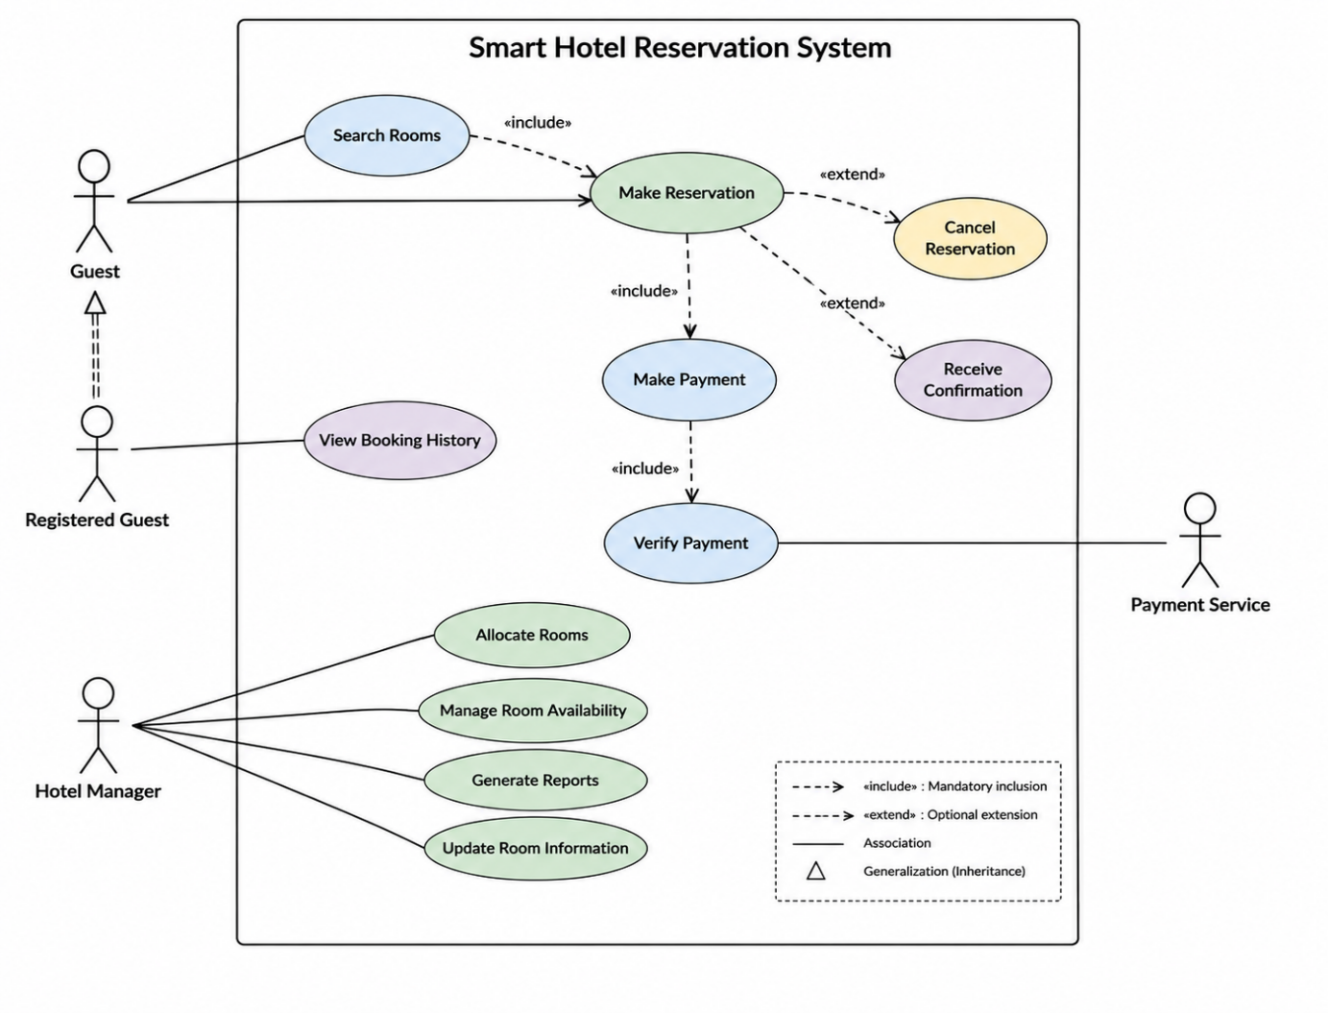

Conclusion
The optimized Use Case Diagram clearly separates the responsibilities of Guests, Registered Guests, Hotel Managers, and the Payment Service. By using <<include>>, <<extend>>, and Generalization relationships, the system becomes easier to understand, maintain, and implement, resulting in a well-structured UML design that satisfies the given requirements.

QUESTION NO. 2 – Class Diagram Design
University Management System

Problem Analysis
The University Management System manages the academic activities of a university. It includes entities such as Student, Faculty, Course, Department, and Examination. The existing design does not clearly define the attributes, methods, and relationships among these classes.
To improve the system, all relevant classes are identified with their attributes and operations. Appropriate UML relationships such as Association, Aggregation, and Inheritance are also applied.

Identified Classes
1. Student
Attributes
- studentID : int
- name : String
- gender : String
- email : String
- phone : String
Methods
- registerCourse()
- viewResult()
- payFees()

2. Faculty
Attributes
- facultyID : int
- name : String
- designation : String
- specialization : String
Methods
- teachCourse()
- assignMarks()
- prepareQuestionPaper()

3. Course
Attributes
- courseID : int
- courseName : String
- credits : int

Methods
- addStudent()
- removeStudent()
- displayCourse()

4. Department
Attributes
- departmentID : int
- departmentName : String
- hodName : String
Methods
- addCourse()
- assignFaculty()
- manageDepartment()

5. Examination
Attributes
- examID : int
- examName : String
- examDate : Date
- totalMarks : int
Methods
- conductExam()
- publishResult()
- calculateGrade()

Relationship Analysis
Association
- Student ↔ Course
- Faculty ↔ Course
- Student ↔ Examination
Aggregation
- Department contains Faculty
- Department contains Course
Inheritance
- Person
  - Student
  - Faculty

Class Diagram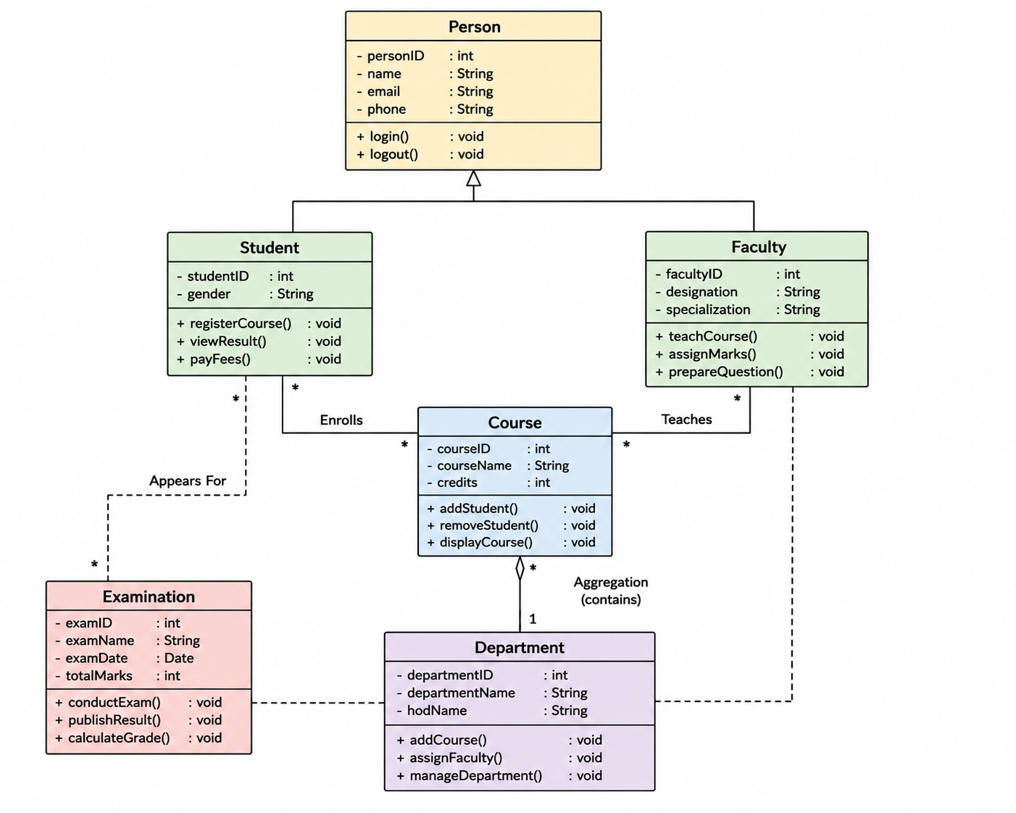

Diagram Explanation
- Person is the parent class containing common attributes like personID, name, email, and phone.
- Student and Faculty inherit from Person, demonstrating Inheritance.
- A Student enrolls in one or more Courses.
- A Faculty member teaches one or more Courses.
- A Department contains multiple Courses and Faculty, representing Aggregation.
- Students appear for Examinations, and the examination publishes results after evaluation.

Conclusion
The proposed Class Diagram provides a structured representation of the University Management System by defining appropriate classes, attributes, methods, and UML relationships. The use of Association, Aggregation, and Inheritance improves modularity, reusability, and maintainability, making the system easier to understand and implement.

QUESTION NO. 3 – Sequence Diagram Evaluation

Vehicle Rental System

Problem Analysis
The Vehicle Rental System allows customers to search for available vehicles, book a vehicle, make payment, and receive a rental confirmation. The existing system lacks proper interaction among system components.
To improve the system, all participating objects and message sequences are identified, ensuring proper communication between the customer, rental system, payment service, vehicle database, and notification service.

Identified Objects
- Customer
- Vehicle Rental System
- Vehicle Database
- Payment Gateway
- Booking Manager
- Notification Service

Sequence of Interactions
Step 1
Customer searches for available vehicles.
Step 2
Vehicle Rental System requests available vehicles from the Vehicle Database.
Step 3
Vehicle Database returns the list of available vehicles.
Step 4
Customer selects a vehicle.
Step 5
Vehicle Rental System sends booking request to Booking Manager.
Step 6
Booking Manager reserves the selected vehicle.
Step 7
Customer makes payment.
Step 8
Vehicle Rental System sends payment request to Payment Gateway.
Step 9
Payment Gateway verifies the payment.
Step 10
Payment Gateway returns payment success.
Step 11
Booking Manager confirms the booking.
Step 12
Notification Service sends rental confirmation to the customer.

Sequence Diagram

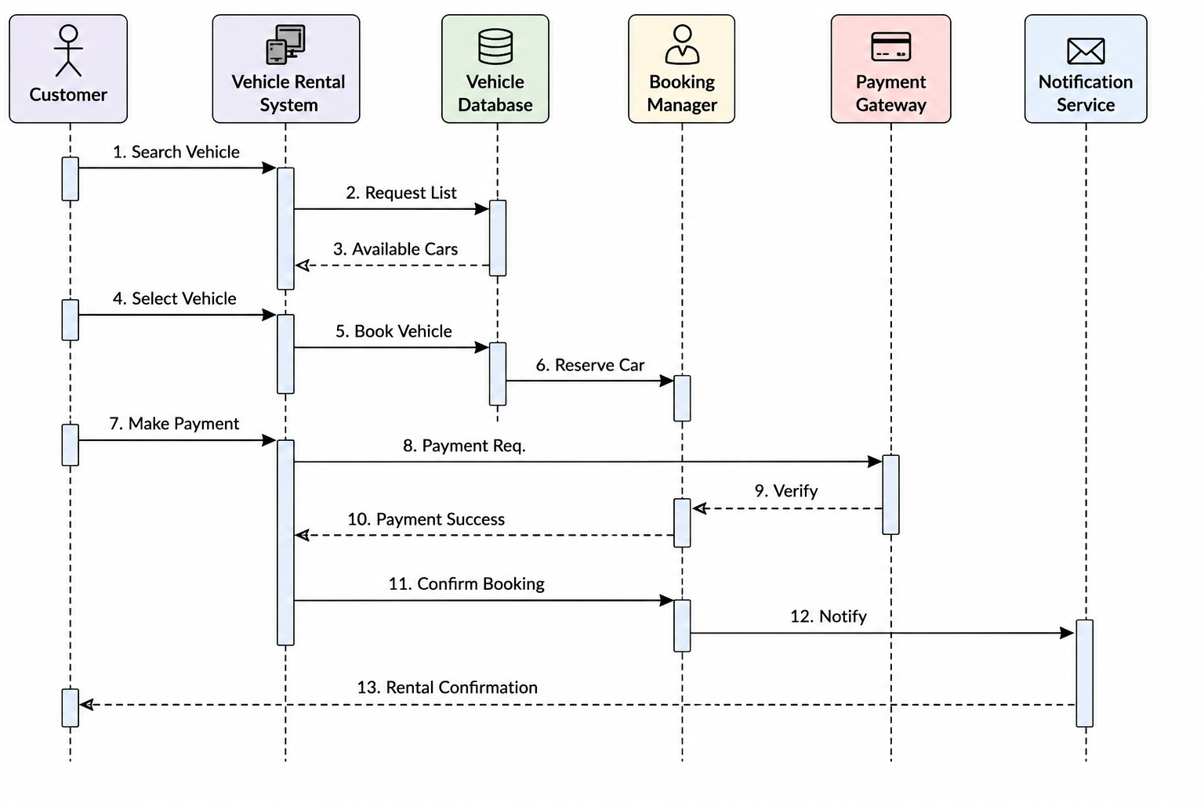

Diagram Explanation
- The Customer searches for available vehicles.
- The Vehicle Rental System retrieves available vehicle details from the Vehicle Database.
- The customer selects a vehicle.
- The system forwards the booking request to the Booking Manager.
- The customer proceeds with payment through the Payment Gateway.
- After successful payment verification, the booking is confirmed.
- Finally, the Notification Service sends the rental confirmation to the customer.

Conclusion
The Sequence Diagram clearly illustrates the interaction between the Customer, Vehicle Rental System, Vehicle Database, Booking Manager, Payment Gateway, and Notification Service. The messages are arranged in chronological order, ensuring a complete and organized booking process. This optimized sequence improves system clarity, communication, and overall efficiency.

QUESTION NO. 4 – State Diagram Construction

Traffic Signal Control System

Problem Analysis
The Traffic Signal Control System manages the flow of vehicles at a road intersection. The system operates through different states such as Red Signal, Green Signal, Yellow Signal, Emergency Mode, and Maintenance Mode. The existing design does not clearly define the transitions between these states.
To improve the system, all valid states, events, and transitions are identified, ensuring that the traffic signal operates safely and efficiently under normal and exceptional conditions.

Identified States
- Initial State
- Red Signal
- Green Signal
- Yellow Signal
- Emergency Mode
- Maintenance Mode
- Final State (System Shutdown)

State Transitions
Normal Operation
- System Start → Red Signal
- Red Signal → Green Signal (Timer Expires)
- Green Signal → Yellow Signal (Timer Expires)
- Yellow Signal → Red Signal (Timer Expires)
Emergency Condition
- Red Signal → Emergency Mode
- Green Signal → Emergency Mode
- Yellow Signal → Emergency Mode
Returning from Emergency
- Emergency Mode → Red Signal
Maintenance
- Any Signal State → Maintenance Mode
- Maintenance Completed → Red Signal
System Shutdown
- Red Signal → Final State

State Transition Diagram
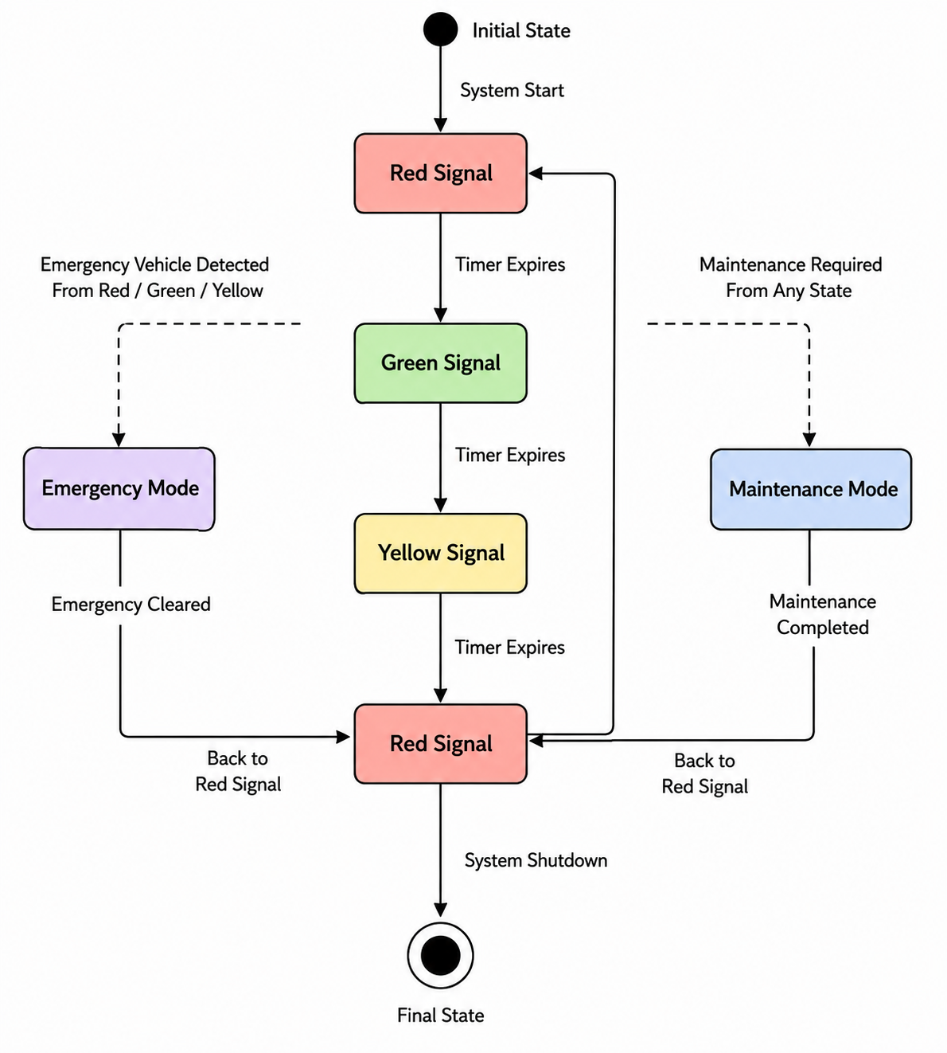

Diagram Explanation
- The system begins at the Initial State and enters the Red Signal state.
- Traffic lights operate in the normal sequence:
  - Red → Green
  - Green → Yellow
  - Yellow → Red
- If an emergency vehicle is detected, the system immediately switches to Emergency Mode from any traffic signal state.
- After the emergency is cleared, the system resumes operation from the Red Signal state.
- If maintenance is required, the system enters Maintenance Mode from any signal state.
- Once maintenance is completed, the system returns to the Red Signal state.
- The system reaches the Final State when it is shut down.

Conclusion
The State Diagram clearly represents the behavior of the Traffic Signal Control System by defining all valid states, events, and transitions. It ensures smooth traffic flow during normal operation while also handling emergency situations and maintenance activities effectively. The optimized state model improves safety, reliability, and overall system performance.

QUESTION NO. 5 – Component Diagram Design

Smart Healthcare Portal

Problem Analysis
The Smart Healthcare Portal provides online healthcare services by managing patients, appointments, medical records, billing, and notifications. The current architecture does not clearly define how different software modules communicate with each other.
To improve the architecture, the major software components, their interfaces, and dependencies are identified. A Component Diagram is designed to show how each module interacts to provide seamless healthcare services.

Identified Components
- Patient Management
- Appointment Scheduling
- Medical Records
- Billing System
- Notification Service
- Database
- Payment Gateway (External Service)

Component Responsibilities
1. Patient Management
- Register patients
- Update patient details
- Manage patient profiles
2. Appointment Scheduling
- Book appointments
- Cancel appointments
- View doctor availability
3. Medical Records
- Store patient history
- View prescriptions
- Update medical records
4. Billing System
- Generate bills
- Calculate charges
- Process payments
5. Notification Service
- Appointment reminders
- Payment confirmation
- Medical report notifications
6. Database
- Stores all healthcare information
- Patient details
- Appointment records
- Medical history
- Billing information
7. Payment Gateway
- Verify payments
- Process online transactions

Component Relationships
Dependency
- Patient Management → Appointment Scheduling
- Appointment Scheduling → Medical Records
- Billing System → Payment Gateway
- Notification Service → Patient Management
Database Connections
- Patient Management ↔ Database
- Appointment Scheduling ↔ Database
- Medical Records ↔ Database
- Billing System ↔ Database

Component Diagram
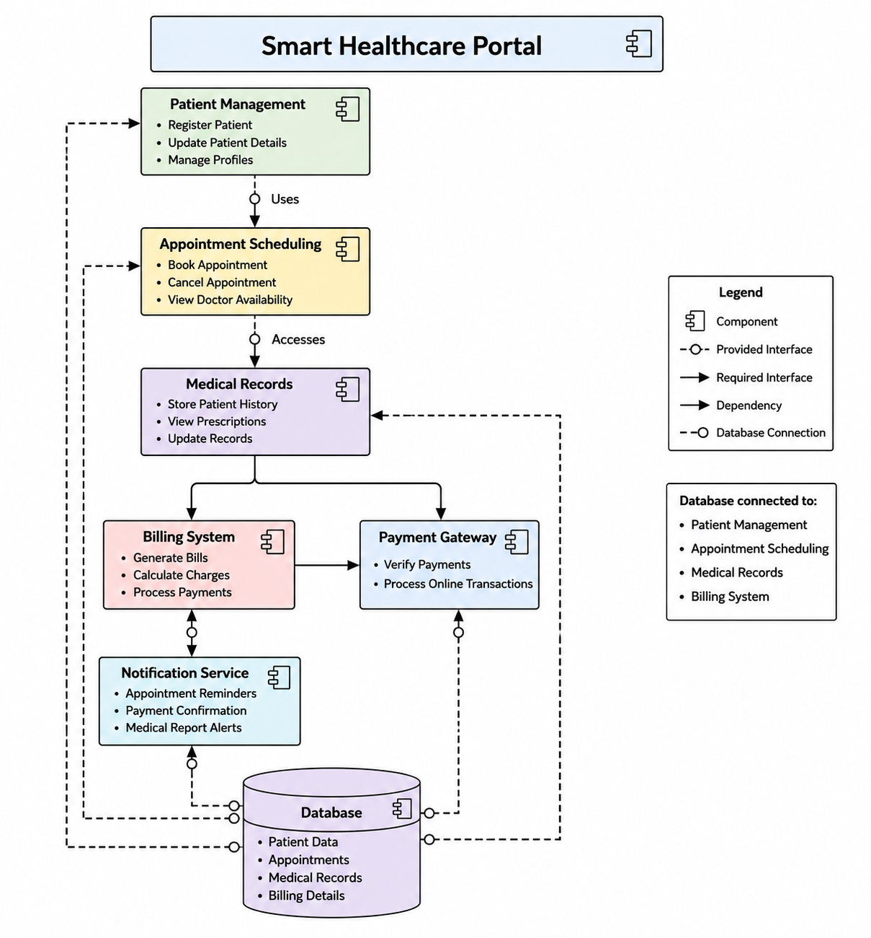

Diagram Explanation
- Patient Management manages patient registration and profile information.
- It communicates with Appointment Scheduling to book or cancel appointments.
- Appointment Scheduling retrieves and updates patient information from the Medical Records component.
- The Billing System generates bills and sends payment requests to the Payment Gateway.
- The Notification Service sends appointment reminders, payment confirmations, and health notifications to patients.
- All major components interact with a centralized Database, which stores patient details, appointments, medical records, and billing information.

Conclusion
The proposed Component Diagram clearly illustrates the interaction among all software components of the Smart Healthcare Portal. It defines the dependencies and interfaces between modules while ensuring centralized data storage through the database. This modular architecture improves scalability, maintainability, and efficient communication between healthcare services.

QUESTION NO. 6 – Deployment Diagram Design

Smart City Waste Management System

Problem Analysis
The Smart City Waste Management System uses IoT technology to monitor waste bins across the city. Smart sensors installed in waste bins detect the fill level and send the data to edge devices. The edge devices forward the data to cloud servers, where it is processed and stored. City authorities monitor the system through a web or mobile dashboard.
The existing design does not clearly define the physical deployment architecture and communication between devices. Therefore, a Deployment Diagram is designed to represent the nodes, artifacts, and communication links.

Identified Nodes
- Smart Waste Bin (IoT Sensor)
- Edge Device
- Cloud Server
- Database Server
- Monitoring Dashboard (Web/Mobile)
- Administrator/User

Artifacts
Smart Waste Bin
- Waste Sensor Software
- Sensor Data
Edge Device
- Data Collection Service
- Communication Module
Cloud Server
- Waste Management Application
- Data Processing Service
- API Services
Database Server
- Waste Bin Data
- Collection Schedule
- User Information
Monitoring Dashboard
- Dashboard Application
- Reports
- Alerts

Communication Links
- Smart Waste Bin → Edge Device (Wi-Fi / LoRa / ZigBee)
- Edge Device → Cloud Server (Internet)
- Cloud Server ↔ Database Server
- Monitoring Dashboard ↔ Cloud Server
- Administrator ↔ Monitoring Dashboard

Deployment Diagram
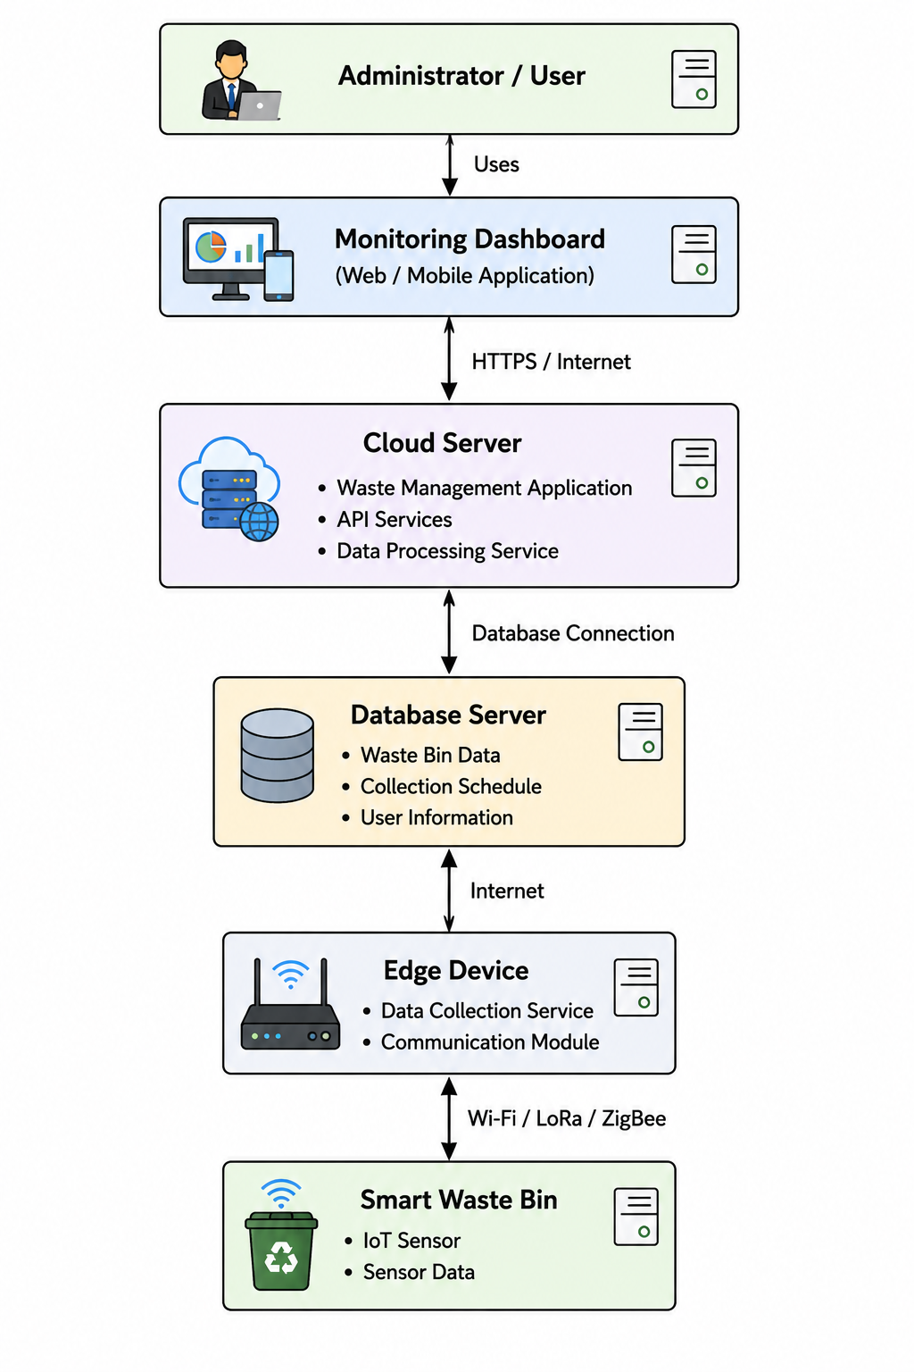
Diagram Explanation
- The Smart Waste Bin contains IoT sensors that monitor the garbage level.
- The collected sensor data is transmitted to the Edge Device using wireless communication technologies such as Wi-Fi, LoRa, or ZigBee.
- The Edge Device forwards the data to the Cloud Server through the Internet.
- The Cloud Server processes the received data and stores it in the Database Server.
- The Monitoring Dashboard retrieves information from the Cloud Server and displays real-time waste-bin status, reports, and alerts.
- The Administrator/User accesses the dashboard to monitor the waste collection process and make decisions.

Conclusion
The Deployment Diagram clearly illustrates the physical architecture of the Smart City Waste Management System by identifying the deployment nodes, software artifacts, and communication links. This architecture enables real-time monitoring, efficient data processing, and centralized management of waste collection, improving scalability, reliability, and overall smart city operations.

